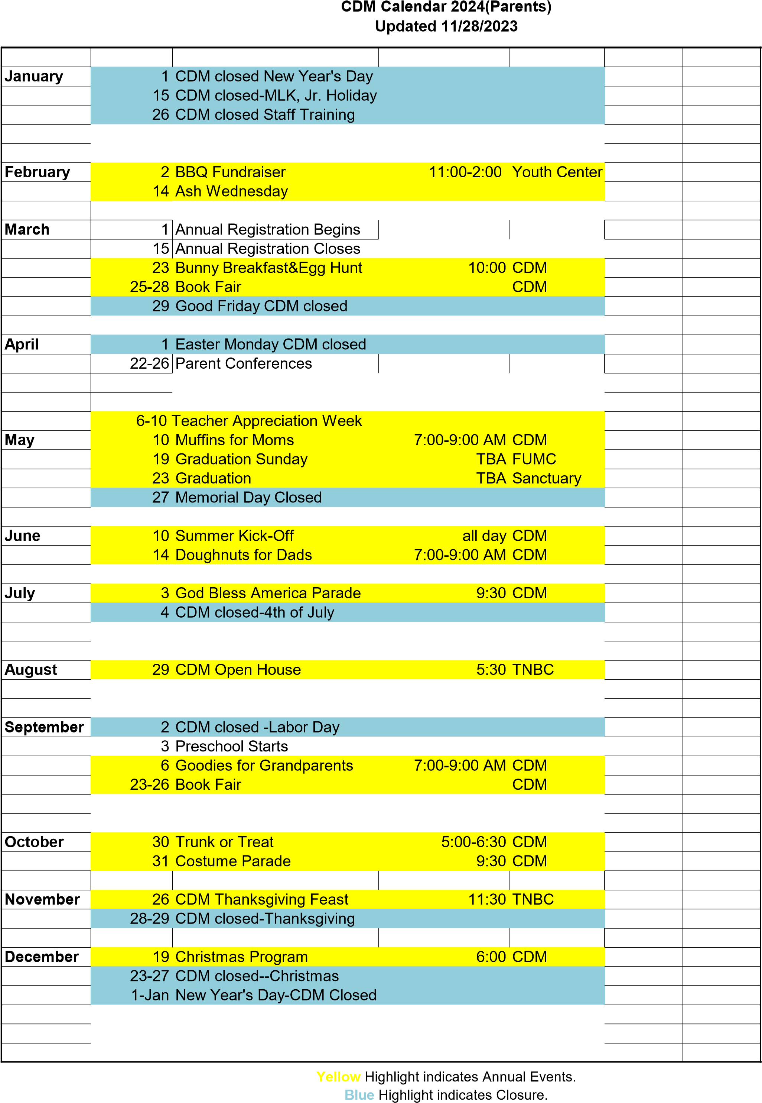
Events may be re-scheduled with advanced notice.

